Title Verification of Deadlock-Free Information Structure
Distribute Mutual Exclusion Algorithms

Student Name Tang Kaijie
Student No. 2014050686
Major Computer Science and Technology
Supervisor Zhang chenyi
Date(dd/mm/yyyy) 22/05/2018

暨 南 大 学
本科生毕业论文

论文题目 无死锁信息结构分布式
互斥算法的验证

学 院_ 国际学院
学 系
专 业 计算机科学与技术
姓 名 汤恺杰
学 号 2014050686
指导教师 张辰一
2018年 5月 22日

Statement of Originality

I hereby declare that the thesis presented is the result of research performed by me personally, under guidance from my supervisor. This thesis does not contain any content (other than those cited with references) that has been previously published or written by others, nor does it contain any material previously presented to other educational institutions for degree or certificate purpose to the best of my knowledge. I promise that all facts presented in this thesis are true and creditable.

Signed: _________________ Date：

Verification of Deadlock-Free Information Structure Distributed
Mutual Exclusion Algorithms

Abstract: In the distributed mutual exclusion problem, several distributed processes in one set must coordinate their state to ensure at any time at most one process may be within its critical section. Deadlock-Free information structure distributed mutual exclusion algorithm (DF-ISDME) is a algorithm which operates on a restricted class of information structures. This paper briefly introduces DF-ISDME and SPIN model checking, using SPIN with linear temporal logic to verify that DF-ISDME is deadlock-free successfully.
Key Words: Distributed Mutual exclusion algorithm, SPIN, Linear temporal logic, Deadlock-Free

无死锁信息结构分布式互斥算法的验证

摘 要: 在信息分布式互斥系统的问题中，多个进程必须协调它们的状态来保证任何时候都最多只有一个进程在临界区中，而无死锁信息结构分布式互斥算法就是一种对这一类分布式互斥的进程进行操作的算法。本文简略介绍了无死锁信息结构分布式互斥算法及SPIN模型检测软件，运用线性时态逻辑对该算法无死锁的特点进行验证。本文通过模型检测后确认该算法在多个进程需要进入临界区时不会发生死锁情况。
关键词: 分布式互斥算法；SPIN；线性时态逻辑；无死锁
Contents
1. Introduction 1
2. Materials and methods 1
2.1 DF-ISDME algorithm 2
2.2 SPIN & PROMELA 4
2.3 Linear temporal logic 5
2.3.1 Syntax 5
2.3.2 Semantic 6
3. Results 7
3.1 Experiment configuration 7
3.2 A DF-ISDME algorithm in PROMELA 8
(1)When the receiving msg is req: 8
(2)When the receiving msg is gr: 9
4. Discussion 10
5. Conclusion 10
Acknowledgements 11
References 12

1. Introduction
A distributed system is a set of distributed process which are connected by a communications network. A process may only be within its critical section(CS) whenever it has gained exclusive access to the shared resource. However, processes can only communicate with each other by message passing since there is no shared memory. The lack of both shared memory and a common clock results in more complex mutual exclusion algorithms than the synchronization primitives typically found when processes share memory. ( Beverly ,1987)
In an ISDME algorithm, each process has a pair of sets called the request set and inform set which form the local information structure. The connection of these pairs defines the global information structure. Deadlock-Free information structure distributed mutual exclusion (DF-ISDME) algorithm does not require a complex deadlock-recovery scheme for deadlock-freedom and it will be described in section 2.
Model checking is a technique for automatically verifying correctness properties of finite-state systems. Since the possible situation is finite in a distributed system, then given a structure of distributed system with DF-ISDME algorithm, exhaustively and automatically check whether this structure meets a deadlock is what we will verify in this paper.

2. Materials and methods
2.1 DF-ISDME algorithm
In this section we present the DF-ISDME algorithm code.
The following set are defined in DF_ISDME algorithm: the request set, R_{i}, and the inform set, I_{i.} The global information structure for a set of processes is the collection of local information structures for each process, i ∈{1 2, ,...,n}. A process i must send a Request message before entering the CS to all the processes which are members of its request set, R_{i} and it must only send Release messages on exiting the CS to the processes which are members of its inform set, I_{i} and we define for each process i the status set, St_{i}. The status set St_{i} is derived from the inform sets of the processes using the following rule,∀ij: I_{i}∈j ↔ St_{j}∈i. A process i keeps track of any processes St_{j}∈i since j must inform i before j enters the CS and after j exits the CS.
The following variables are used by a process i: The request set R_{i} and the inform set I_{i} which form the local information structure together with the status set St_{i} derived from I_{i} . A logical clock clk which is used to tag each Request message sent by i with a logical time t such that the next value of t will be one greater than the highest time value that i has received thus far. A priority request queue Q_{i} which maintains an ascending order sorted list of the timestamps associated with Request messages received by process i. A timestamp is a tuple consisting of the time value of a Request together with the process identifier of the process making the request. A timestamp ( i,t_{i} ) i is less than (has higher priority) than a timestamp ( j,t_{j} ) , written ( i,t_{i} ) < ( j,t_{j} ) , when ( t_{i} <t_{j} )∨( t_{i =} t_{j} ∧i < j ) holds. The function priority_insr(Q_{i} ,( j,t_{j} ) ) returns a new priority queue inserting the timestamp ( j,t_{j} ) into the priority request queue described by the current value of Q_{i} . Send statements are of the form send_{i} ( j,msg ) which sends the message represented by the tuple msg to the channel associated with process j. Receive statements are of the form recv_{i} ( msg ) which receives the next message from the channel associated with process i into the tuple described by msg.
The DF-ISDME algorithm for a process i is defined by the following program code:
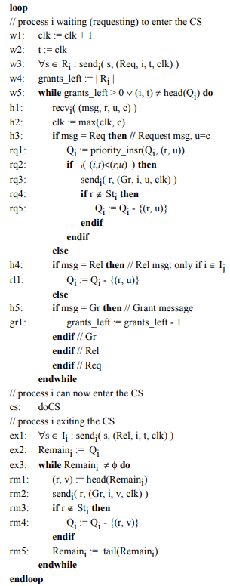
Figure 2-1 Programming Code of DF-ISDME(1)
From the program code, a process i enters the waiting region, w1..w5, chooses a time value t, and tries to gain permission to enter the CS by sending Request (Req) messages to all the members of its request set, R_{i}. Process i's current request to enter is noted in t to be compared against any other requesting processes. Whenever a process i receives a Request message (see h1..h3) from a process j, it inserts j's request timestamp into Q_{i}. Now if i's pending request t is of lower priority (higher time value) than j's then i will immediately send a Grant(Gr) message to j. At this point ( see rq4..rq5), j's timestamp can be deleted from Q_{i} but only if it is not a member of i's status set St_{i}. If i's pending request t is not of lower priority than j's then i will retain j's timestamp in Q_{i} and the Grant message to j will be delayed. Process i will only reach the CS after it has received Grant messages from all the processes in its request set R_{i} (grants_left=0) and its own request timestamp is at the head of Q_{i}. On leaving the CS, a process i enters the exit region, ex1..ex3, and sends Release (Rel) messages to all the processes in its inform set, I_{i} (For a process I_{j} ∈ i, this will have the effect of removing i's timestamp, see rl1, from Q_{j}). Now, process i has had its turn and can immediately send Grant messages to the processes in Q_{i} (whose requests were delayed). Again, at this point ( see rm3..rm4), j's timestamp can be deleted from Q_{i} but only if it is not a member of i's status set St_{i .}
Figure 2-2 Programming Code of DF-ISDME(2)
2.2 SPIN & PROMELA
Spin targets the efficient verification of multi-threaded software, not the verification of hardware circuits. The tool supports a high level language to specify systems descriptions called Process Meta Language(PROMELA).
PROMELA is a process modeling language whose intended use is to verify the logic of parallel systems. Given a program in PROMELA, Spin can verify the model for correctness by performing random or iterative simulations of the modeled system's execution, or it can generate a C program that performs a fast exhaustive verification of the system state space. During simulations and verifications SPIN checks for the absence of deadlocks, unspecified receptions, and unexecutable code. The verifier can also be used to prove the correctness of system invariants and it can find non-progress execution cycles. Finally, it supports the verification of linear time temporal constraints; either with PROMELA never-claims or by directly formulating the constraints in temporal logic. Each model can be verified with SPIN under different types of assumptions about the environment. Once the correctness of a model has been established with SPIN, that fact can be used in the construction and verification of all subsequent models.
SPIN has been used to trace logical design errors in distributed systems design, such as operating systems, data communications protocols, switching systems, concurrent algorithms, railway signaling protocols, control software for spacecraft, nuclear power plants, etc. The tool checks the logical consistency of a specification and reports on deadlocks, race conditions, different types of incompleteness, and unwarranted assumptions about the relative speeds of processes.(Bell Labs, 1980)
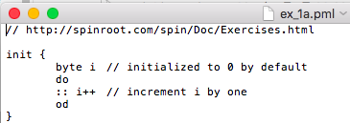
Figure2-3 An example PROMELA program
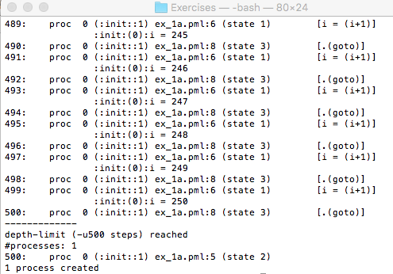
Figure2-4 The result of the PROMELA program in Figure2-3 when it running with SPIN
2.3 Linear temporal logic
2.3.1 Syntax
LTL is built up from a finite set of propositional variables AP, the logical operators ¬ and ∨, and the temporal modal operators X and U. The set of LTL formulas over AP is inductively defined as follows:
- If p ∈ AP then p is an LTL formula;
- If ψ and φ are LTL formulas then ¬ψ, φ ∨ ψ, X ψ, and φ U ψ are LTL formulas. (Baier and Katoen,2010)
X is read as next and U is read as until. Other than these fundamental operators, there are additional logical and temporal operators defined in terms of the fundamental operators to write LTL formulas succinctly. The additional logical operators are ∧, →, ↔, true, and false. Following are the additional temporal operators.( Sickert, 2017 )
G for always (globally).
F for eventually (in the future)
R for release
W for weakly until
M for strong release

2.3.2 Semantic
An LTL formula can be satisfied by an infinite sequence of truth evaluations of variables in AP. These sequences can be viewed as a word on a path of a Kripke structure. Let w = a₀,a₁,a₂,... be such an ω-word. Let w(i) = a_{i}. Let w^{i} = a_{i},a_{i+1},..., which is a suffix of w. Formally, the satisfaction relation |= between a word and an LTL formula is defined as follows:
- w|= p if p ∈ w(0)
- w|= ¬ψ if w |≠ ψ
- w|= φ ∨ ψ if w |= φ or w |= ψ
- w|= X ψ if w¹|= ψ (in the next time step ψ must be true)
- w|= φ U ψ if there exists i ≥ 0 such that w^{i} |= ψ and for all 0 ≤ k < i, w^{k} |= φ (φ must remain true until ψ becomes true)
An ω-word w satisfies an LTL formula ψ when w |= ψ. The ω-language L(ψ) defined by ψ is {w | w |= ψ}, which is the set of ω-words that satisfy ψ. A formula ψ is satisfiable if there exist an ω-word w such that w |= ψ.A formula ψ is valid if for each ω-word w over alphabet 2^{AP}, w |= ψ.
The additional logical operators are defined as follows:
- φ ∧ ψ ≡ ¬(¬φ ∨ ¬ψ)
- φ → ψ ≡ ¬φ ∨ ψ
- φ ↔ ψ ≡ (φ → ψ) ∧ ( ψ → φ)
- true ≡ p ∨ ¬p, where p ∈ AP
- false ≡ ¬true
The additional temporal operators R, F, and G are defined as follows:
- φ R ψ ≡ ¬(¬φ U ¬ψ) ( ψ remains true until and including once φ becomes true. If φ never become true, ψ must remain true forever.)
- F ψ ≡ true U ψ (eventually ψ becomes true)
- G ψ ≡ false R ψ ≡ ¬F ¬ψ (ψ always remains true)
The semantics for the temporal operators are pictorially presented as follows.

Table 2-1 Semantics for some temporal operations
Textual | Symbolic | Explanation
Xφ | ○φ | next: φ has to hold at the next state.
Fφ | ◇φ | Finally: φ eventually has to hold (somewhere on the subsequent path).
Gφ | □φ | Globally: φ has to hold on the entire subsequent path.

3. Results
3.1 Experiment configuration
The operating system of my computer is OS X EI Capitan, the version of SPIN and gcc are shown as follow.
Figure3-1 SPIN’s version
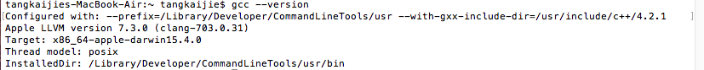
Figure3-2 gcc’s version
3.2 A DF-ISDME algorithm in PROMELA
The information structure for this model, R1={1,2}, R2={1,2}, I1=φ, I2=φ. The request message req and grant message gr in mtype msg and check point of the critical section mutex are defined globally, and the following variables are used by a process i: the send&receive channel ( chan sr[i-1] which contains { mtype, byte, byte, byte }), current time ( byte t[i-1]), global time ( byte clk[i-1]), grants left ( byte gl[i-1]), the priority queue ( chan q_{i} which contains { short }), a calculation storage for priority comparison ( byte head ), since the earlier process ( which is shown as the time is smaller in program) will have higher priority, we set ( t₁ , u₁ ) > ( t₂ , u₂ ) if t₁ * 4 + u₁ < t₂ * 4 + u₂ so that we need to store the result from the receive channel sr[i-1], the check point of the priority queue q_{i} ( short item ), the rest part of the priority queue q_{i -}( chan tmp which contains { short }), the parameter receive from sr[i-1] ( { msg, r, u, c }) such as process number (byte r ) , message sending time ( byte u ) and global time ( byte c ).
In a process i, first we set the R_{i} , initialize clk[i-1] into 0. Then we set the sending part of the process i . Run the protocol twice assuming it doesn’t overflow clk[i-1]&t[i-1]: increasing clk[i-1], set the gl[i-1] = num( R_{i} ), t[i-1]=clk[i-1], and send the requests { req, i, t[i-1] ,clk[i-1] } by sr[R_{i}[j]-1] where j means all the agents in R_{i} .
( for example, in process 1 will send the requests as follow:
for( j in R₁ ){
sr[R₁[j]-1]!req,1,t[0],clk[0] ) } )
Next we a the do-while loop as the receiving part of the process i to receive the message from itself or other process by sr[i-1]?msg,r,u,c. c is used for updating the local clock clk[i-1] by c>clk[i-1] -> clk[i-1] = c. msg is used for distinguishing the different message( req&gr ).
(1)When the receiving msg is req:
r,u are used for comparing the priority. Define head = u*4+r compare with the current head t[i-1]+1. If head is smaller( has higher priority ), send out a grant message to sr[head%4-1] by sr[head%4-1]!gr,i,head/4,clk[i-1], otherwise we check whether this request source is in St_{i} or not. If it is, then add it into q_{i} by q_{i}!!head ( q_{i}!!head is sorted sending) , otherwise we skip it. ( here we confirm that r in St_{i} first, we then add it into the priority queue. It is more efficient than first inserting (r,u) then removing the pair )
(2)When the receiving msg is gr:
Gl[i-1] decreasing.
After receiving a message the process need to check whether the gl[i-1] is equal to zero. If it does, then it can go to the critical section CS, otherwise it go back to receiving part to waiting the grant message.
At last the critical section CS increase and decrease mutex assuming the process i is running. Then we send grant messages for all request messages remaining in q_{i} and only remove the request when it is not in St_{i} . First check whether q_{i} is empty or not, if it is, then it come to an end, otherwise we send q_{i} to tmp by item as follow:
q_{i}?item -> sr[item%4-1]!gr,i,item/4,clk[0]
if item%4 is not in St_{i}, remove that from q_{i}, that is, not to copy it to tmp ( as follow ):
if
item%4 != i -> tmp!item
else -> skip
Fi
At last we move tmp back to q_{i} :
do
empty(tmp)->break;
tmp?item -> q1!item
od
Then the complete process is finished and we can check whether it is mutual exclusion or not with the linear temporal logic formula ltl {[](mutex < 2)} since if there is more than one process in the critical section CS, the mutex must larger than 2. If there is an error, it means this is not a information structure distributed mutual exclusion algorithm. There will be more then one process within the critical section CS.
Then we test the PROMELA program with 2 process , 3 process and change the LTL formula into ltl {[](mutex < 1)} to check whether it is reliable. The result shows that the PROMELA program is reliable and the DF-ISDME is actually mutual exclusion.
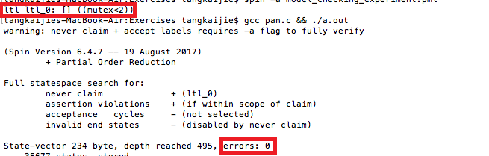
Figure3-3 An example result of the DF-ISDME ( 2 processes, mutex<2)
4. Discussion
In this section we will discuss what is mutual exclusion and how to prove it.
In computer science, mutual exclusion is a property of concurrency control, which is instituted for the purpose of preventing race conditions; it is the requirement that one thread of execution never enter its critical section at the same time that another concurrent thread of execution enters its own critical section.
The requirement of mutual exclusion was first identified and solved by Edsger W. Dijkstra in his seminal 1965 paper titled Solution of a problem in concurrent programming control, ( Taubenfeld , 2004) which is credited as the first topic in the study of concurrent algorithms. (Dijkstra,1965)
A simple example of why mutual exclusion is important in practice can be visualized using a singly linked list of four items, where the second and third are to be removed. The removal of a node that sits between 2 other nodes is performed by changing the next pointer of the previous node to point to the next node (in other words, if node i is being removed, then the next pointer of node i − 1 is changed to point to node i + 1, thereby removing from the linked list any reference to node i). When such a linked list is being shared between multiple threads of execution, two threads of execution may attempt to remove two different nodes simultaneously, one thread of execution changing the next pointer of node i − 1 to point to node i + 1, while another thread of execution changes the next pointer of node i to point to node i + 2. Although both removal operations complete successfully, the desired state of the linked list is not achieved: node i + 1 remains in the list, because the next pointer of node i − 1 points to node i + 1. ( Dijkstra,1974 )
This problem can be avoided by using the requirement of mutual exclusion to ensure that simultaneous updates to the same part of the list cannot occur.
The term mutual exclusion is also used in reference to the simultaneous writing of a memory address by one thread while the aforementioned memory address is being manipulated or read by another thread or other threads.
Every process can be partitioned into four sections, resulting in four states. Program execution cycles through these four states in order:
(1)Non-Critical Section: Operation is outside the critical section; the process is not using or requesting the shared resource.
(2)Trying: The process attempts to enter the critical section.
(3)Critical Section:The process is allowed to access the shared resource in this section.
(4)Exit:The process leaves the critical section and makes the shared resource available to other processes.
If a process wishes to enter the critical section, it must first execute the trying section and wait until it acquires access to the critical section. After the process has executed its critical section and is finished with the shared resources, it needs to execute the exit section to release them for other processes' use. The process then returns to its non-critical section. ( Lamport , 1986)
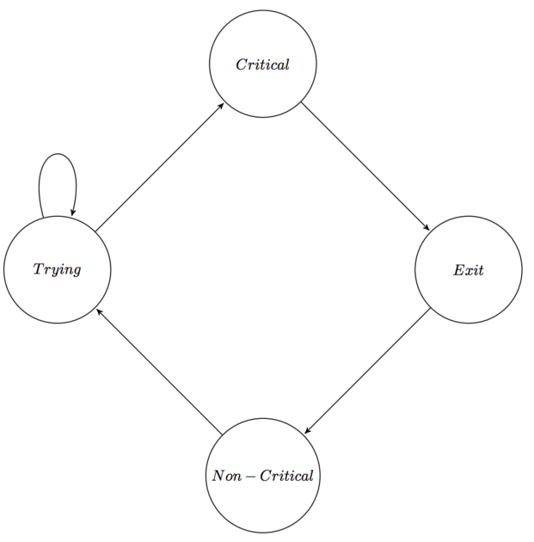
Figure4-1 State cycle for a single process
5. Conclusion

Acknowledgements

References
Bell Labs (1980). What is spin?
Retrieved from:
http://spinroot.com/spin/what.html
(accessed 18 JAN 2018)
Beverly A. Sanders (1987). The information structure of distributed mutual exclusion algorithms.ACM Transactions on Computer Systems (TOCS), 5(3),284-299.
Christel Baier & Joost-Pieter Katoen (2010). Principles of Model Checking.
Retrieved from:
http://mitpress.mit.edu/catalog/item/default.asp?tid%3D11481%26ttype%3D2
(accessed 5 APR 2018)
Edsger Wybe Dijkstra (1965). Solution of a problem in concurrent programming control. Communications of the ACM ,8(9), pp569.
Edsger Wybe Dijkstra (1974). Self-stabilizing systems in spite of distributed control. Communications of the ACM ,17(11), pp643-644.
Leslie Lamport (1986). The Mutual Exclusion Problem – Part II: Statements and Solutions. Journal of the Association for Computing Machinery, 33(2), pp313-348.
Pradip K. Srimani & S.R.Das.. Distributed Mutual Exclusion Algorithms. IEEE Computer Society Press, California, 1992.
Salomon Sickert. (2017). Linear Temporal Logic.
Retrieved from:
https://www.isa-afp.org/browser_info/current/AFP/LTL/document.pdf
(accessed 4 APR 2018)
Gadi Taubenfeld (2004) The Black-White Bakery Algorithm and Related Bounded-Space, Adaptive, Local-Spinning and FIFO Algorithms. In 18th International Symposium on Distributed Computing,18, 56-70.
Umberto Bonollo & Elizabeth A. Sonenberg(1996). Deadlock-Free Information Structure Distributed Mutual Exclusion Algorithms. In the 19th ACSC Conference, Melbourne, Australia, Jan 31 - Feb 2, 1996.

Graduation Thesis Evaluation for Undergraduate Students
Supervisor’s Comments：

Marks：_______/100 Signature：
Date (dd/mm/yyyy):
Evaluator’s Comments:

Marks：_______/100 Signature：
Date (dd/mm/yyyy):
Dean’s Comments:

Marks: _______/100 Signature：
Date (dd/mm/yyyy):

